System Dynamics Homework #4
102303022 賴言厚 機械4A
程式
%HW4-4
clc;
clear;
num = [8 25];
den = [1 8 25];
sys = tf (num,den);
[y,t] = step (sys,10);
figure(1);
plot(t,y)
title('4');
xlabel('Time (t)'); ylabel('y(t)');
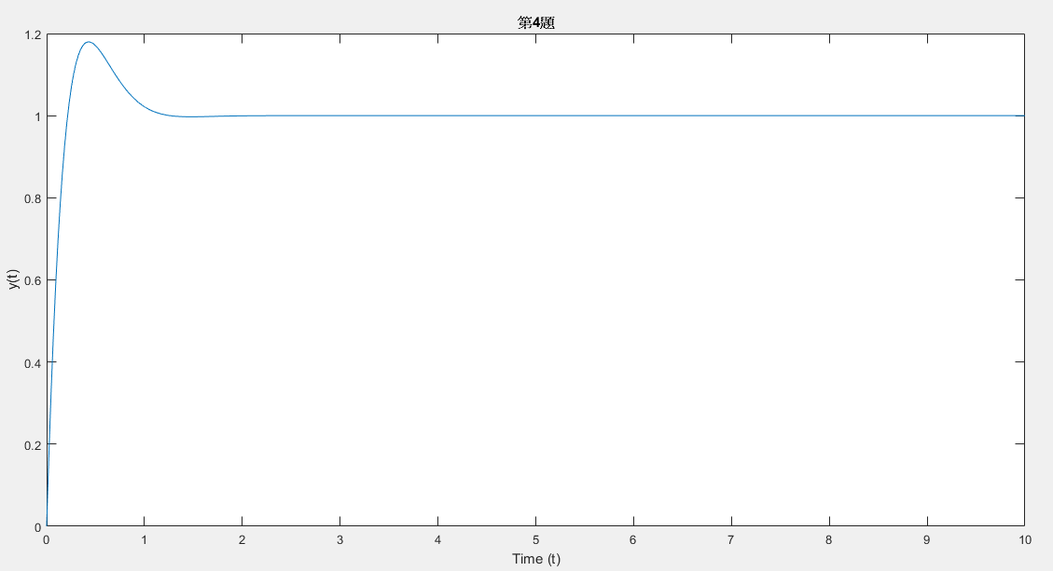
%HW4-5
clear;
figure(2);
t=0:0.001:100;
u=sin(t);
num = [8 25];
den = [1 8 25];
sys = tf ( num, den );
y = lsim(sys,u,t);
plot(t,y)
title('5');
xlabel('Time (t)'); ylabel('y(t)');
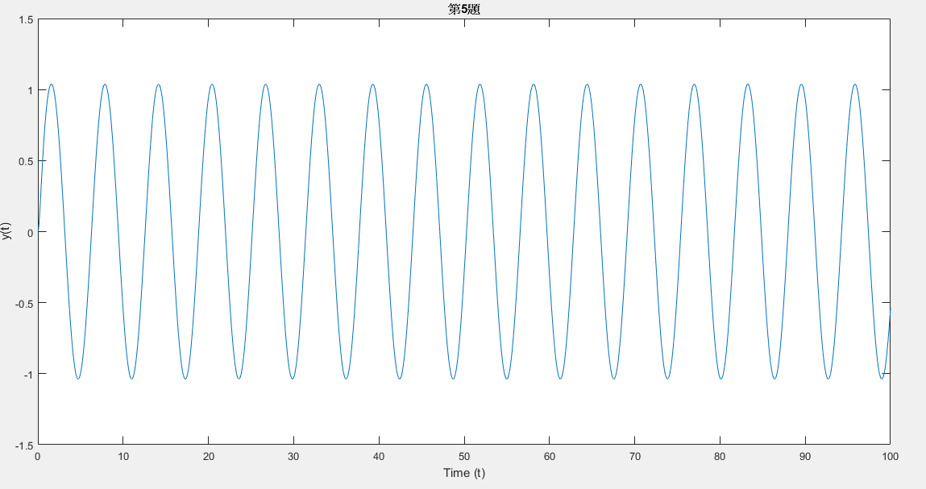
%HW4-6
%a*y"(t)+b*y'(t)+y(t) = u(t)
clear
figure(3);
a = 1; b = 1;
num = [1];
den = [a b 1];
sys = tf ( num, den );
[y t] = step(sys,70);
plot(t,y,'+')
hold on;
a = 10; b = 1;
num = [1];
den = [a b 1];
sys = tf ( num, den );
[y t] = step(sys,70);
plot(t,y,'*')
hold on;
a = 20; b = 2;
num = [1];
den = [a b 1];
sys = tf ( num, den );
[y t] = step(sys,70);
plot(t,y,'.')

a = 1; b = 10;
num = [1];
den = [a b 1];
sys = tf ( num, den );
[y t] = step(sys,70);
plot(t,y,'^')
hold on;
a = 1; b = 20;
num = [1];
den = [a b 1];
sys = tf ( num, den );
[y t] = step(sys,70);
plot(t,y,'-')
title('6');
xlabel('Time (t)'); ylabel('y(t)');
legend('a=1,b=1','a=10,b=1','a=20,b=1','a=1,b=10','a=1,b=20');
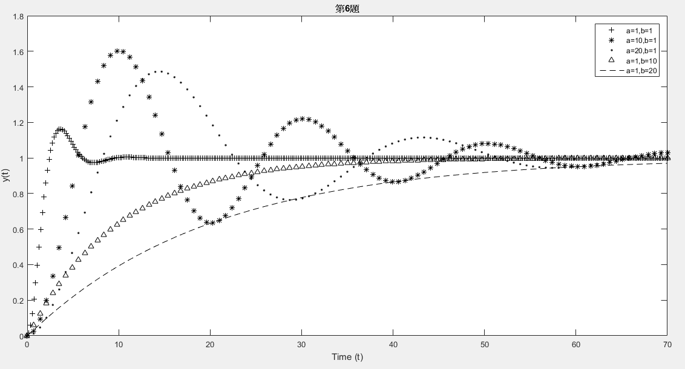
說明
第6題:
隨著a的增加達到steady state的時間較慢 而隨著b的增加overshoot不見了,且達到steady state的時間也較慢

